[![Review Assignment Due Date](https://classroom.github.com/assets/deadline-readme-button-22041afd0340ce965d47ae6ef1cefeee28c7c493a6346c4f15d667ab976d596c.svg)](https://classroom.github.com/a/XoLGRbHq)

[![Open in Visual Studio Code](https://classroom.github.com/assets/open-in-vscode-2e0aaae1b6195c2367325f4f02e2d04e9abb55f0b24a779b69b11b9e10269abc.svg)](https://classroom.github.com/online_ide?assignment_repo_id=15280404&assignment_repo_type=AssignmentRepo)

# SE-Assignment-5

Installation and Navigation of Visual Studio Code (VS Code)

Instructions:

Answer the following questions based on your understanding of the installation and navigation of Visual Studio Code (VS Code). Provide detailed explanations and examples where appropriate.

Questions:

1. Installation of VS Code:

- Describe the steps to download and install Visual Studio Code on Windows 11 operating system. Include any prerequisites that might be needed.

**1. Download VS Code:**

* Head over to the official VS Code download page: [download VS Code].
* Select the appropriate download for your system. It will likely be the ".exe" installer for Windows.

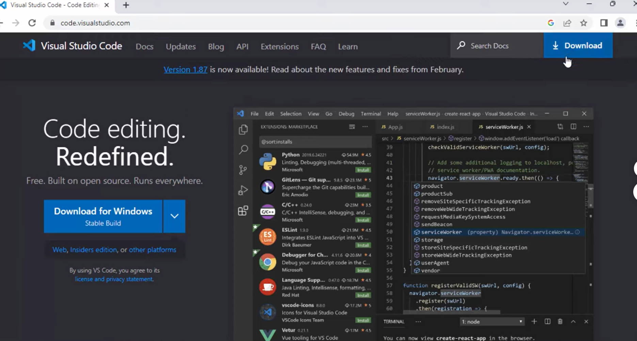

**2. Run the Installer:**

* Double-click the downloaded installer (VSCodeUserSetup-{version}.exe).
* Follow the on-screen instructions. Typically, you'll just need to accept the license agreement and choose an installation location (default is recommended).

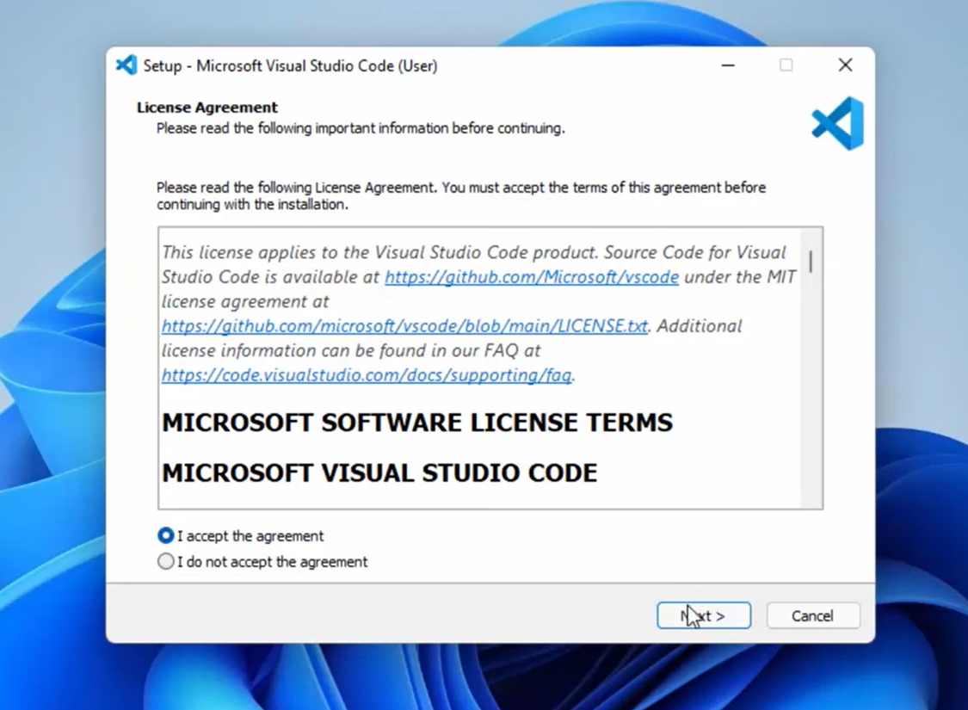

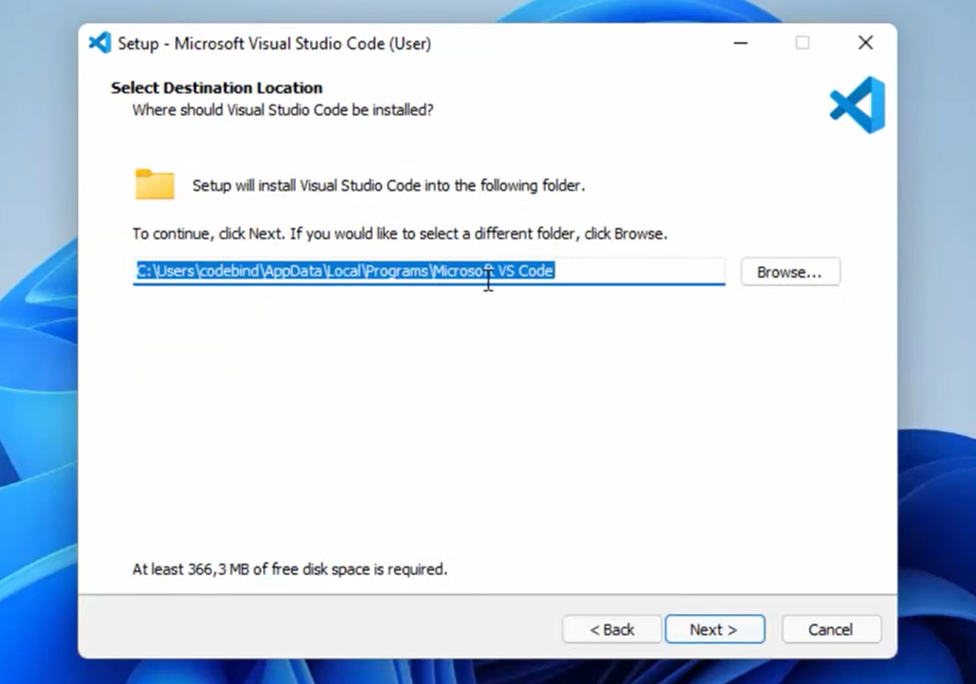

Complete the additional tasks;

a .Create a desktop icon

b. Add “Open with Code” actions to the windows explorer context menu.

c. Add “Open with Code” actions to the windows explorer directory context menu.

d. Register Code as an editor for supported file types.

e. Add to path

**Add VS Code to PATH(optional):**

* By default, the installer might add VS Code to your system PATH environment variable. This allows you to launch VS Code from any directory in your command prompt or terminal.
* If you want to confirm or manually add it, search for "environment variables" in your Windows search bar and edit the system environment variables.
* Under "System variables," find the "Path" variable and click "Edit."
* If the path to VS Code's installation directory (e.g., "C:\Users&lt;username>\AppData\Local\Programs\Microsoft VS Code") is present, you're good to go. Otherwise, click "New" and add the path.

**Then Install the visual studio code by clicking “install” button and wait for a few seconds.**

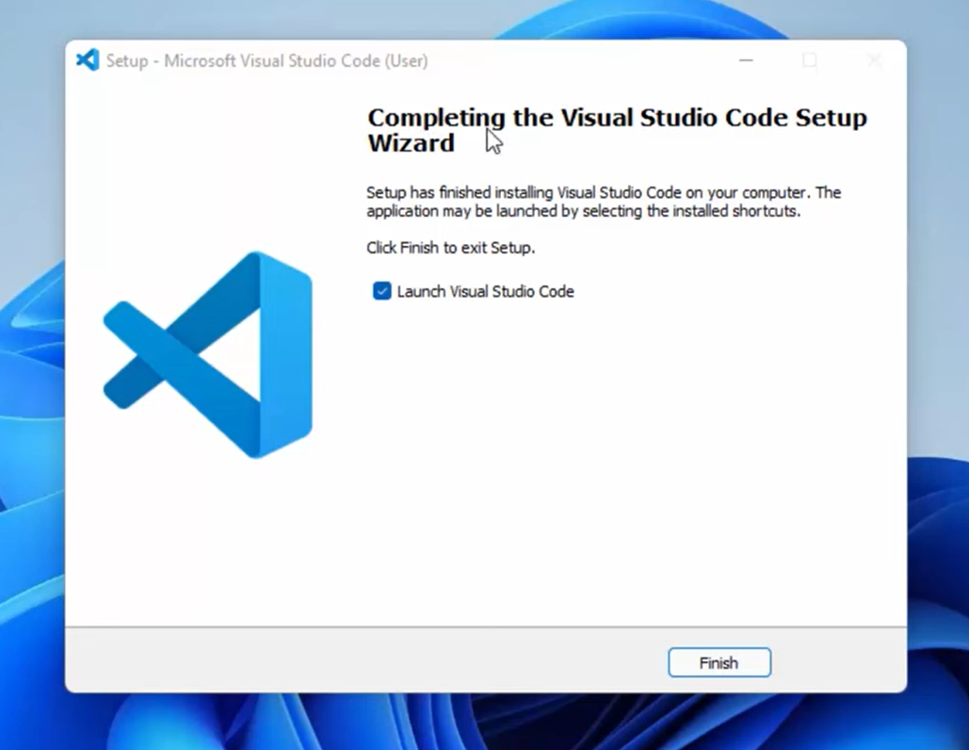

By clicking the “finish” button; the visual studio launches automatically;

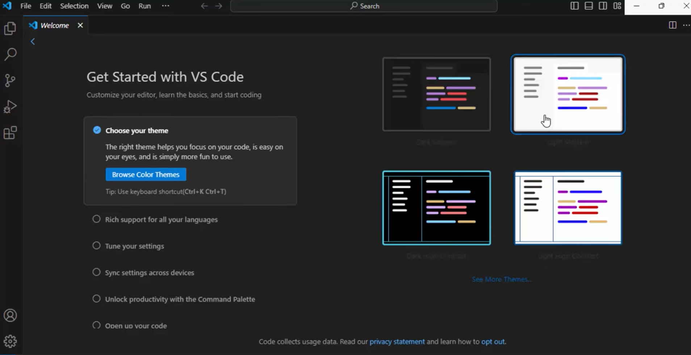

Once installed, you can launch VS Code from the Start Menu or by searching for "VS Code" in the Windows search bar.

**You've successfully downloaded and installed Visual Studio Code on your Windows system.**

2. First-time Setup:

- After installing VS Code, what initial configurations and settings should be adjusted for an optimal coding environment? Mention any important settings or extensions.

After installing VS Code, there are several initial configurations and settings that should be adjusted for an optimal coding environment. Some important settings and extensions to consider include:

1. Syntax highlighting and code completion: Install the appropriate language extension (e.g., "Python", "JavaScript", etc.) to enable syntax highlighting and code completion.

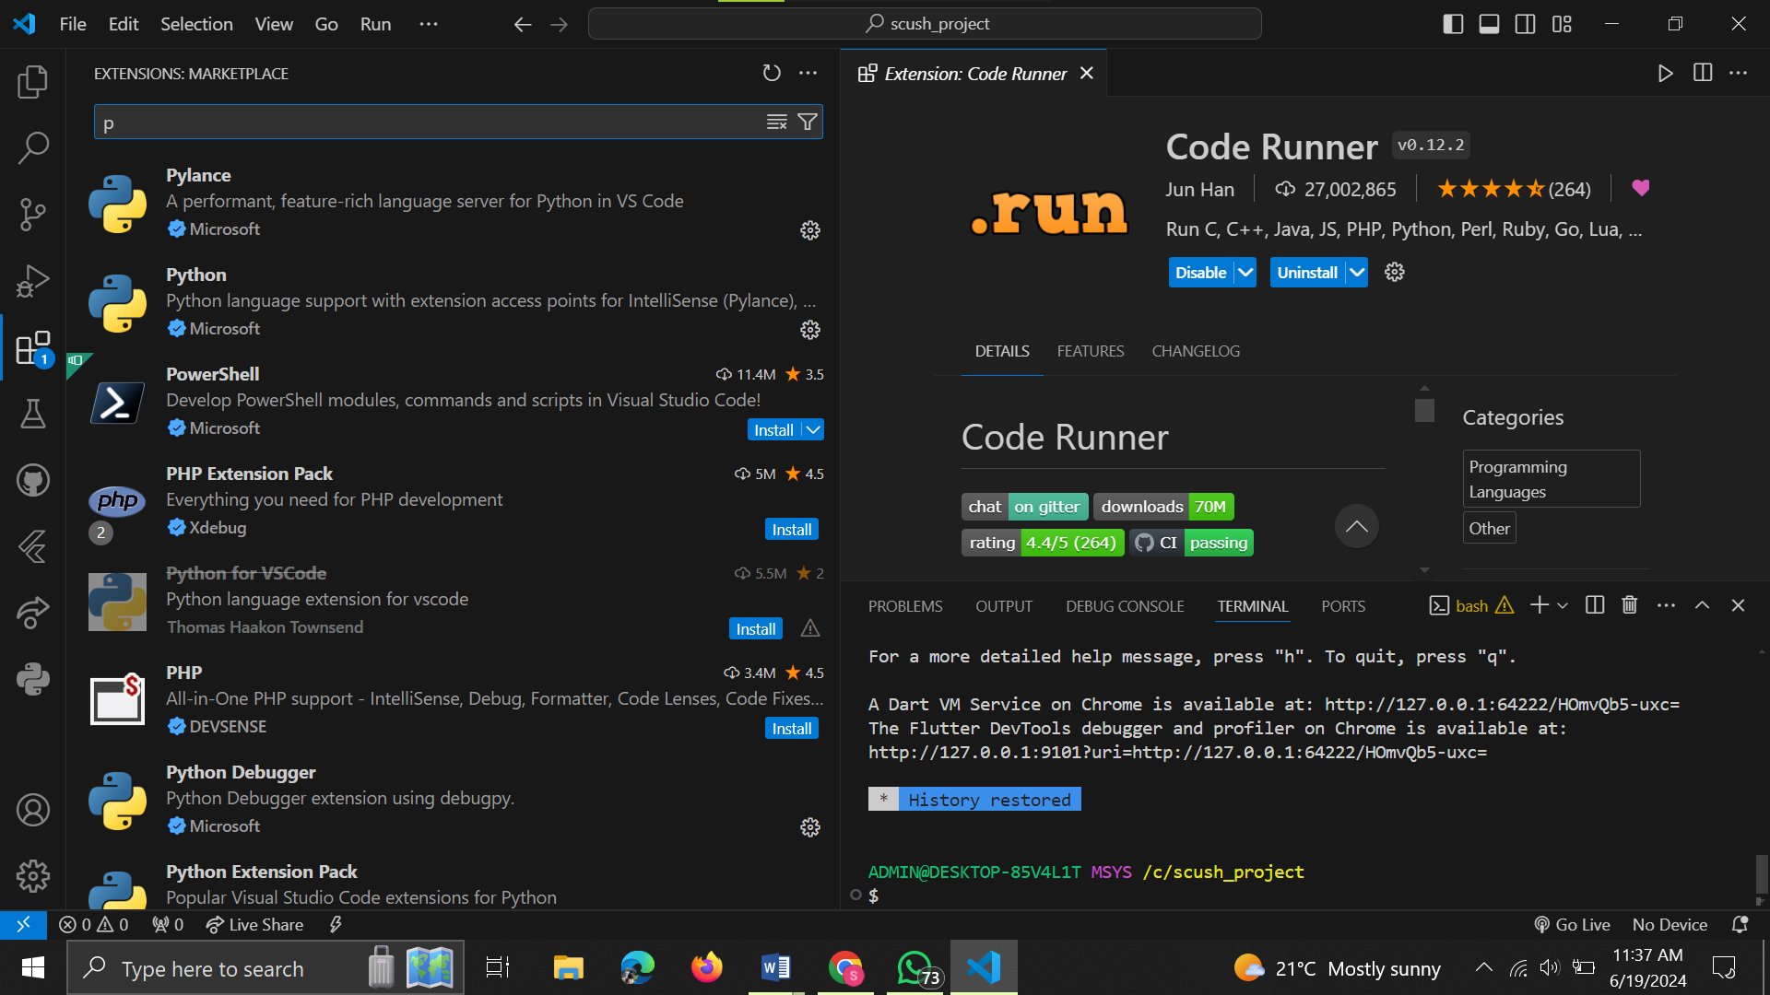

1. Theme: Choose a theme that improves readability and personalizes your coding experience. Some popular themes include "Dark", "Light", and "Material Theme".

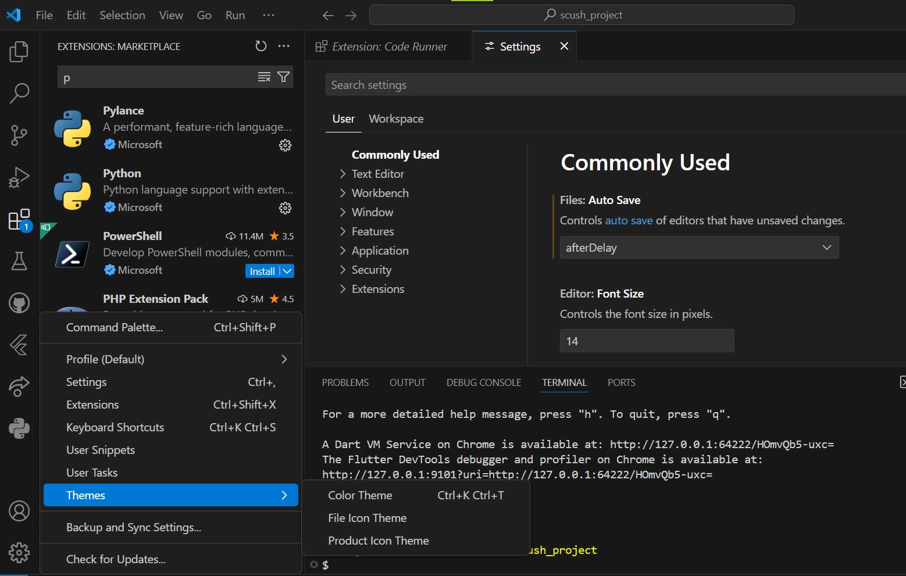

1. Font size and font: Adjust the font size and font to your preferred settings for better readability.
2. Keybindings: Customize keybindings to improve productivity and workflow.

3. User Interface Overview:

- Explain the main components of the VS Code user interface. Identify and describe the purpose of the Activity Bar, Side Bar, Editor Group, and Status Bar.

The VS Code user interface is divided into several main components:

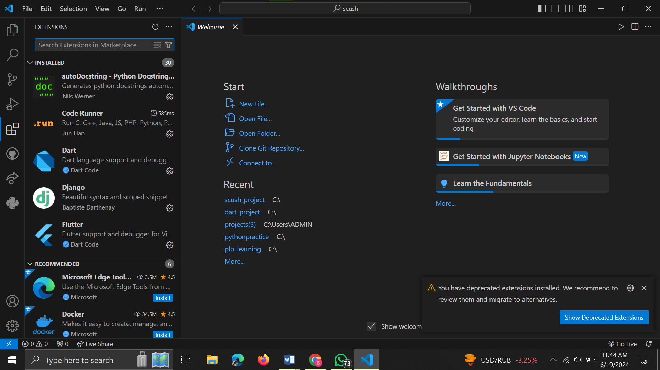

* Activity Bar: Located on the left side of the window, the Activity Bar provides quick access to various VS Code features, such as files, folders, terminals, and extensions.

* Side Bar: Located on the left side of the window, the Side Bar displays a file explorer view of the current workspace or project. It allows users to navigate and manage files and folders efficiently.

* Editor Group: The main area of the VS Code window is the Editor Group, where users can write and edit code. It supports multiple code editors, allowing users to work on multiple files or code snippets simultaneously.

* Status Bar: Located at the bottom of the window, the Status Bar displays information about the current file, such as the file path, line and column numbers, and the number of characters, words, and lines in the file. It also provides quick access to various VS Code features, such as saving, debugging, and version control.

4. Command Palette:

- What is the Command Palette in VS Code, and how can it be accessed? Provide examples of common tasks that can be performed using the Command Palette.

The Command Palette in VS Code is a powerful tool that allows users to access a wide range of VS Code features and extensions using keyboard shortcuts. To access the Command Palette, press Ctrl + Shift + P (Windows/Linux) or Cmd + Shift + P (Mac).

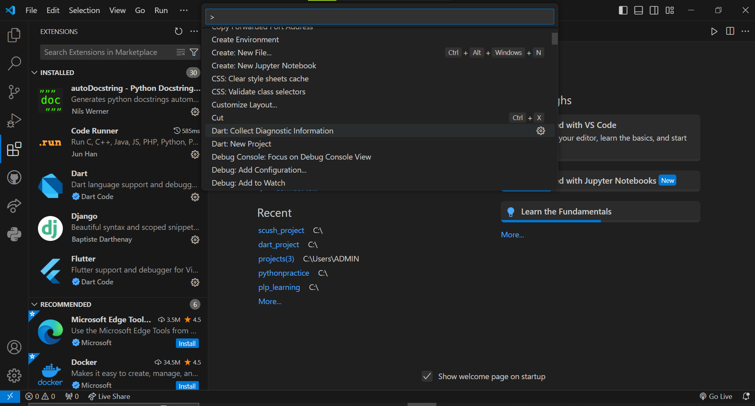

Some examples of common tasks that can be performed using the Command Palette include:

1. Code navigation: Use the Go to Symbol command to quickly navigate to any symbol (variable, function, class, etc.) in your code.
2. Code completion: Use the Auto Complete command to enable code completion for the current language.
3. File management: Use the Open File or Open Folder command to open files or folders in your workspace.
4. Extension management: Use the Extensions: Install Extensions command to search for and install new extensions.

5. Extensions in VS Code:

- Discuss the role of extensions in VS Code. How can users find, install, and manage extensions? Provide examples of essential extensions for web development.

Extensions in VS Code enhance the functionality of the editor by providing additional features, such as code completion, syntax highlighting, debugging tools, and more. Users can find and install extensions from the Extensions Marketplace within VS Code:

1. Open the Extensions Marketplace by clicking on the Extensions icon in the Activity Bar (looks like a small square with a downward arrow).
2. Search for the desired extension using the search bar.
3. Click on the extension to open its page, which displays information about the extension, its version, and user reviews.
4. Click on the "Install" button to install the extension.
5. Once the extension is installed, you can enable or disable it by clicking on the extension icon in the Extensions Marketplace or by pressing Ctrl + Shift + P and typing "Extensions: Toggle [extension name]".

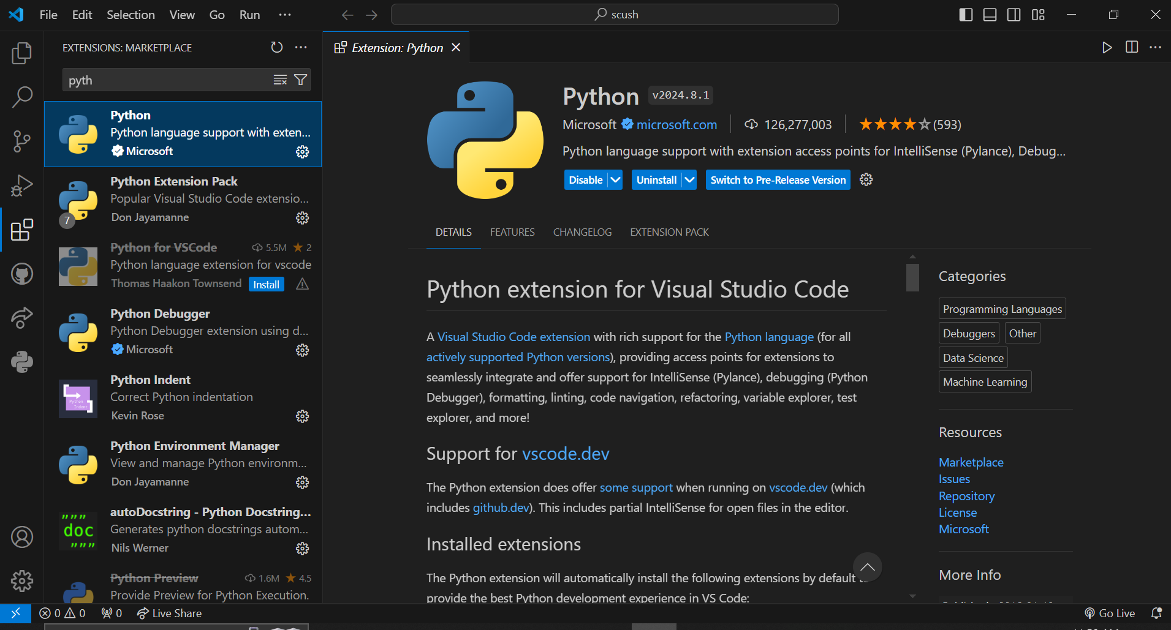

Some essential extensions for web development include:

1. "ms-vscode-js-debugger": A debugger for JavaScript and TypeScript applications.
2. "dbaeumer.vscode-eslint": A plugin that integrates ESLint into VS Code, providing code linting and code completion.
3. "stylelint.vscode.stylelint": A plugin that integrates Stylelint into VS Code, providing code linting for CSS and other styling languages.

6. Integrated Terminal:

- Describe how to open and use the integrated terminal in VS Code. What are the advantages of using the integrated terminal compared to an external terminal?

The integrated terminal in VS Code allows users to open and manage multiple terminals within the editor, which can be useful for running commands, executing scripts, and interacting with the file system. To open the integrated terminal, follow these steps:

1. Click on the Terminal icon in the Activity Bar (looks like a small square with a downward arrow).
2. Alternatively, press `Ctrl + Shift + ` (Windows/Linux) or `Cmd + Shift + ` (Mac) to open a new terminal window.

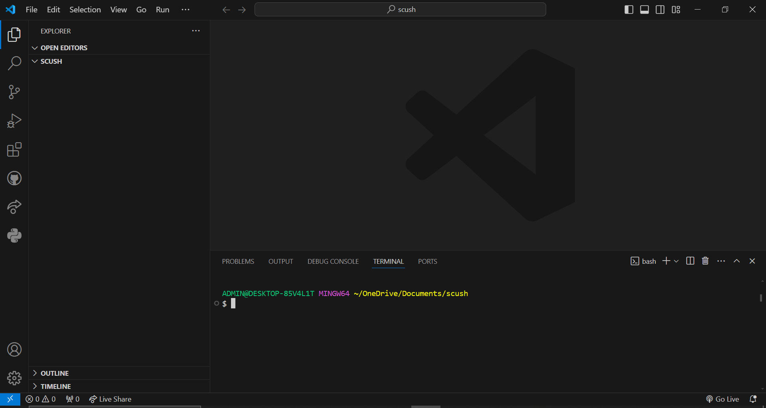

The integrated terminal has several advantages over an external terminal, including:

1. Better integration with VS Code, allowing users to easily switch between code editors and the terminal.
2. Improved visibility and accessibility, as the terminal is always accessible within the VS Code window.
3. Enhanced productivity, as users can perform various tasks, such as running scripts, executing commands, and interacting with the file system, without needing to open an external terminal window.

7. File and Folder Management:

- Explain how to create, open, and manage files and folders in VS Code. How can users navigate between different files and directories efficiently?

To create, open, and manage files and folders in VS Code, follow these steps:

1. To create a new file, click on the "New File" button in the Explorer view (located on the left side of the VS Code window) or press Ctrl + N.

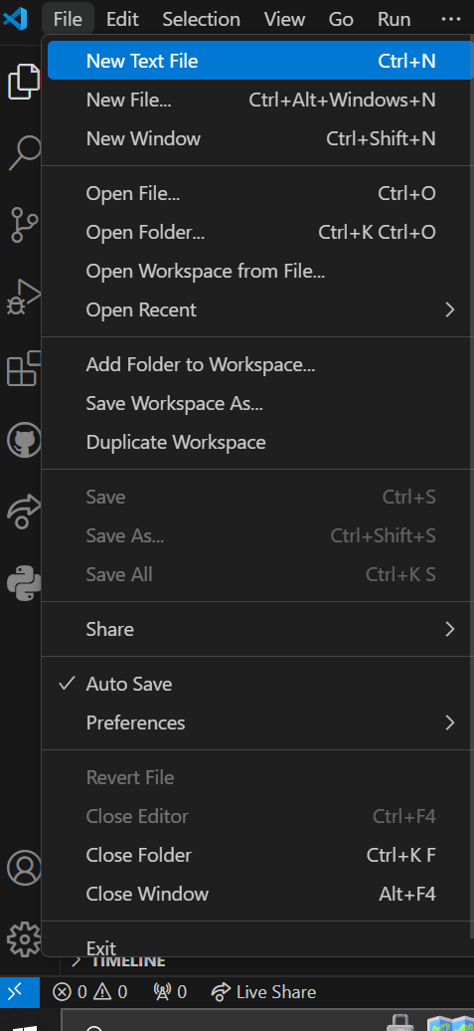

1. To create a new folder, click on the "New Folder" button in the Explorer view or press Ctrl + Shift + N.

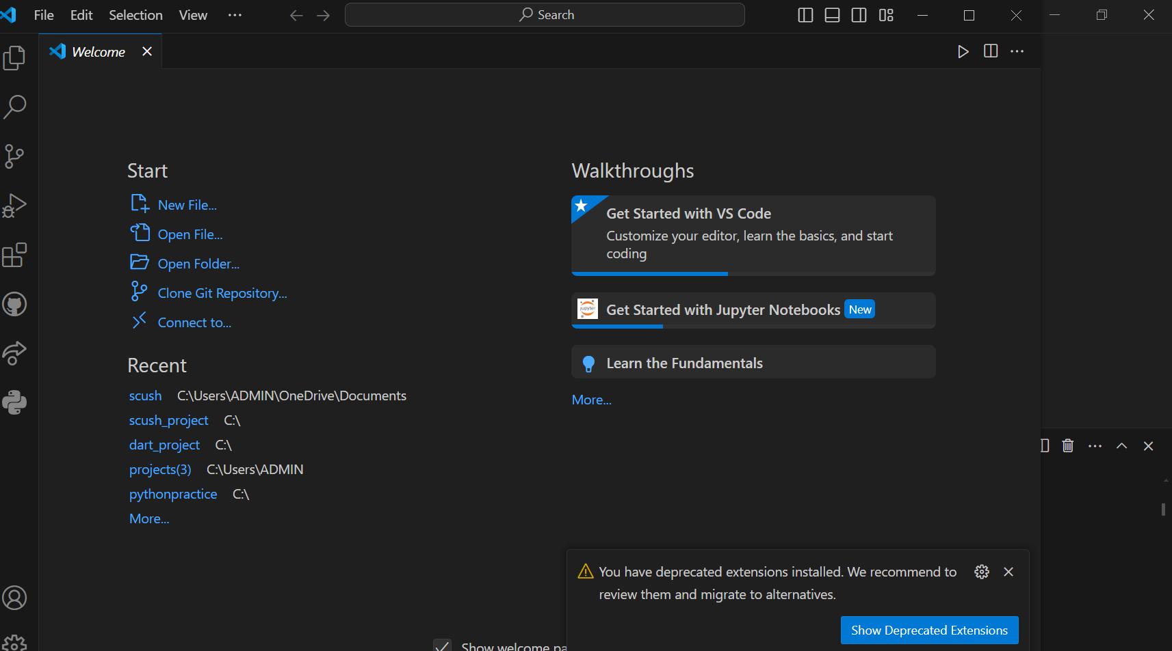

1. To open an existing file or folder, double-click on the file or folder in the Explorer view or click on it and press Enter.

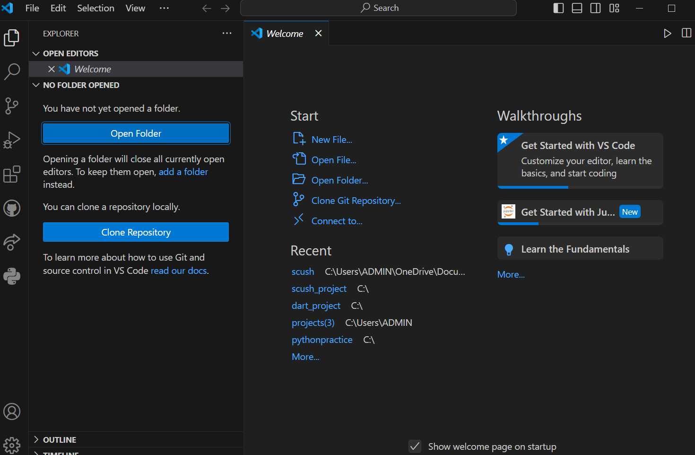

1. To navigate between different files and directories efficiently, use the Explorer view to browse and manage files and folders. Users can also use keyboard shortcuts, such as Ctrl + Tab to switch between open files or Ctrl + Shift + T to open a file by name.

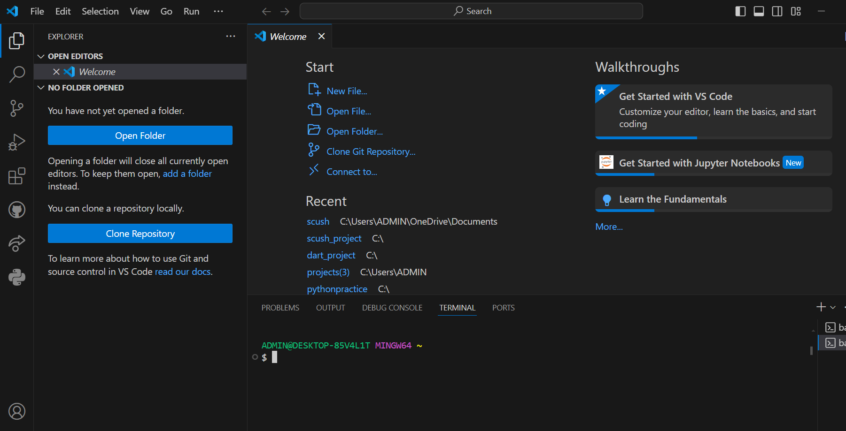

8. Settings and Preferences:

- Where can users find and customize settings in VS Code? Provide examples of how to change the theme, font size, and keybindings.

Users can find and customize settings in VS Code by following these steps:

1. To access the settings, click on the gear icon in the bottom left corner of the VS Code window or press Ctrl + Shift + P and type "Preferences: Open Settings (JSON)".
2. In the settings file, users can customize various settings, such as the theme, font size, and keybindings. For example, to change the theme, users can add the following line to the settings file:
3. json
4. "workbench.colorTheme": "Dark",
5. To save the changes, click on the "File" menu and select "Save" or press Ctrl + S.
6. Alternatively, users can also access and customize settings through the VS Code user interface:
7. To change the theme, click on the gear icon in the bottom left corner of the VS Code window and select "Theme: Select Theme" from the dropdown menu.
8. To change the font size, click on the gear icon in the bottom left corner of the VS Code window and select "Preferences: Editor Font Size" from the dropdown menu.
9. To change keybindings, click on the gear icon in the bottom left corner of the VS Code window and select "Preferences: Keyboard Shortcuts" from the dropdown menu.

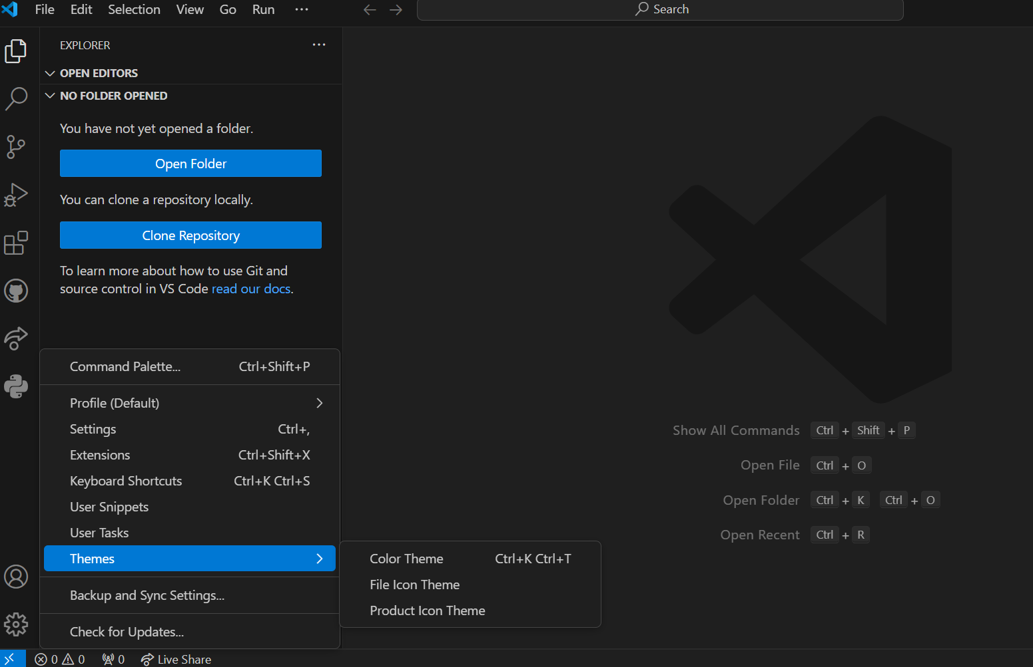

9. Debugging in VS Code:

- Outline the steps to set up and start debugging a simple program in VS Code. What are some key debugging features available in VS Code?

To set up and start debugging a simple program in VS Code, follow these steps:

1. Create a new file with a .js extension and write some sample JavaScript code, such as:
2. javascript
3. console.log("Hello, World!");
4. Save the file and open it in VS Code.
5. To set up debugging, click on the gear icon in the bottom left corner of the VS Code window and select "Debug: Open Configuration (JSON)".
6. In the debug configuration file, add the following lines to configure the debugger:
7. json
8. {
9. "name": ".vscode/launch.json",
10. "version": "0.2.0",
11. "configurations": [
12. {
    1. "name": ".vscode/launch.json",
    2. "type": "node",
    3. "request": "launch",
    4. "program": "${file}",
    5. "sourceFileMap": {
    6. "${file}": "${file}"
    7. },
    8. "outFiles": [],
    9. "sourceRoot": "${workspaceFolder}/src"
13. }
14. ]
15. }
16. Save the changes and close the debug configuration file.
17. To start debugging, click on the gear icon in the bottom left corner of the VS Code window and select "Debug: Start Debugging" from the dropdown menu.
18. The debugger will attach to the running process and allow users to set breakpoints, inspect variables, and step through code.
19. Some key debugging features available in VS Code include:
20. Breakpoints: Users can set breakpoints in their code to pause the execution of the program at specific points.
21. Watch Expressions: Users can watch the value of variables and expressions as the program* Call Stack: Users can view the call stack to understand the flow of the program and identify where they are in the code.
22. Variables View: Users can view and inspect the values of variables in the Variables view.

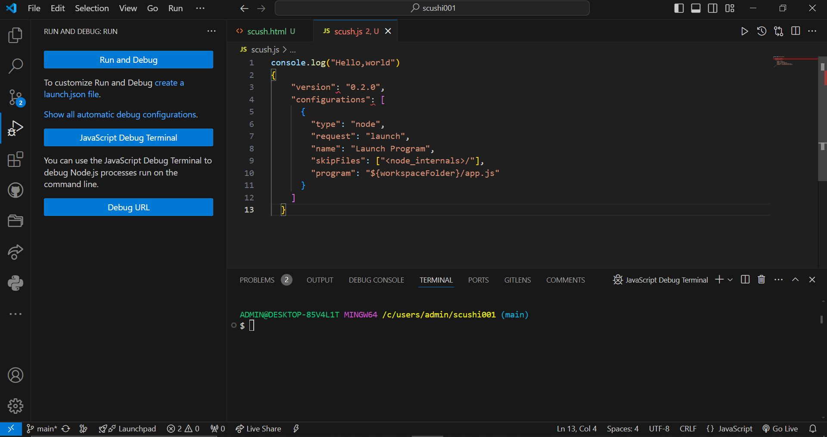

10. Using Source Control:

- How can users integrate Git with VS Code for version control? Describe the process of initializing a repository, making commits, and pushing changes to GitHub.

To integrate Git with VS Code for version control, follow these steps:

1. Install the Git extension for VS Code:

* Open VS Code and click on the Extensions icon in the left sidebar (looks like a small square with an arrow pointing to the right).
* Search for "Git" in the Extensions Marketplace and install the "Git: Version Control" extension.

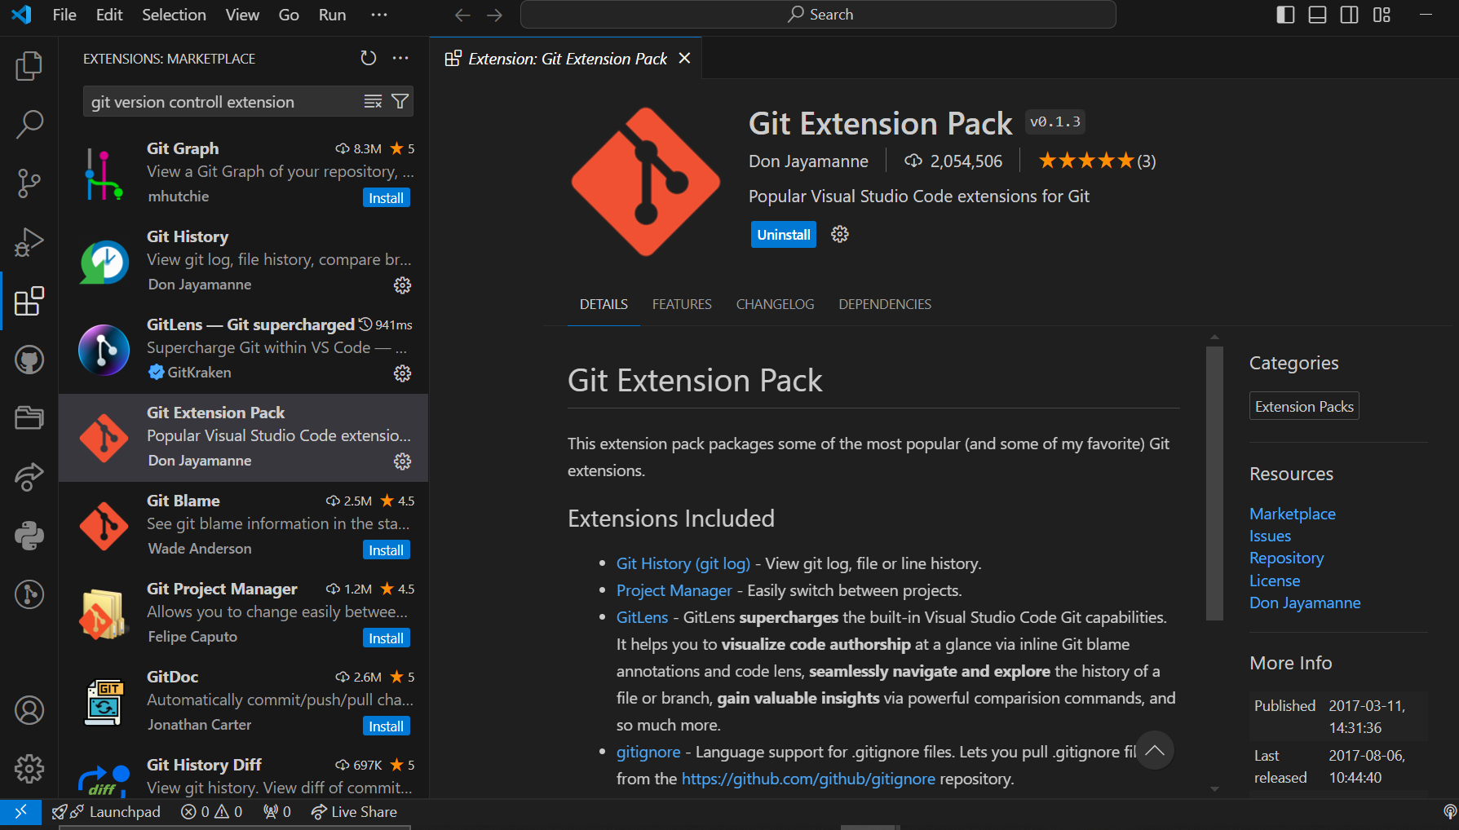

* Restart VS Code after installation.

2. Initialize a Git repository:

* Open the folder containing the files you want to version control in VS Code.
* Click on the Git icon in the bottom left corner of the VS Code window (looks like a small green commit icon).
* Select "Initialize Repository" from the dropdown menu.

3. Make changes to the files:

* Make some changes to the files in the repository, such as adding or modifying code, deleting files, or creating new files.

4. Stage changes:

* Click on the Git icon in the bottom left corner of the VS Code window and select "Git: Add" from the dropdown menu.
* This will stage the changes you made to the files.

5. Commit changes:

* Click on the Git icon in the bottom left corner of the VS Code window and select "Git: Commit" from the dropdown menu.
* In the commit message box, enter a brief description of the changes you made and click on the "Commit" button.

6. Push changes to GitHub:

* Click on the Git icon in the bottom left corner of the VS Code window and select "Git: Push" from the dropdown menu.
* Enter your GitHub username and password, or use your SSH key to authenticate with the remote repository.
* Select the branch you want to push the changes to (usually "main" or "master").

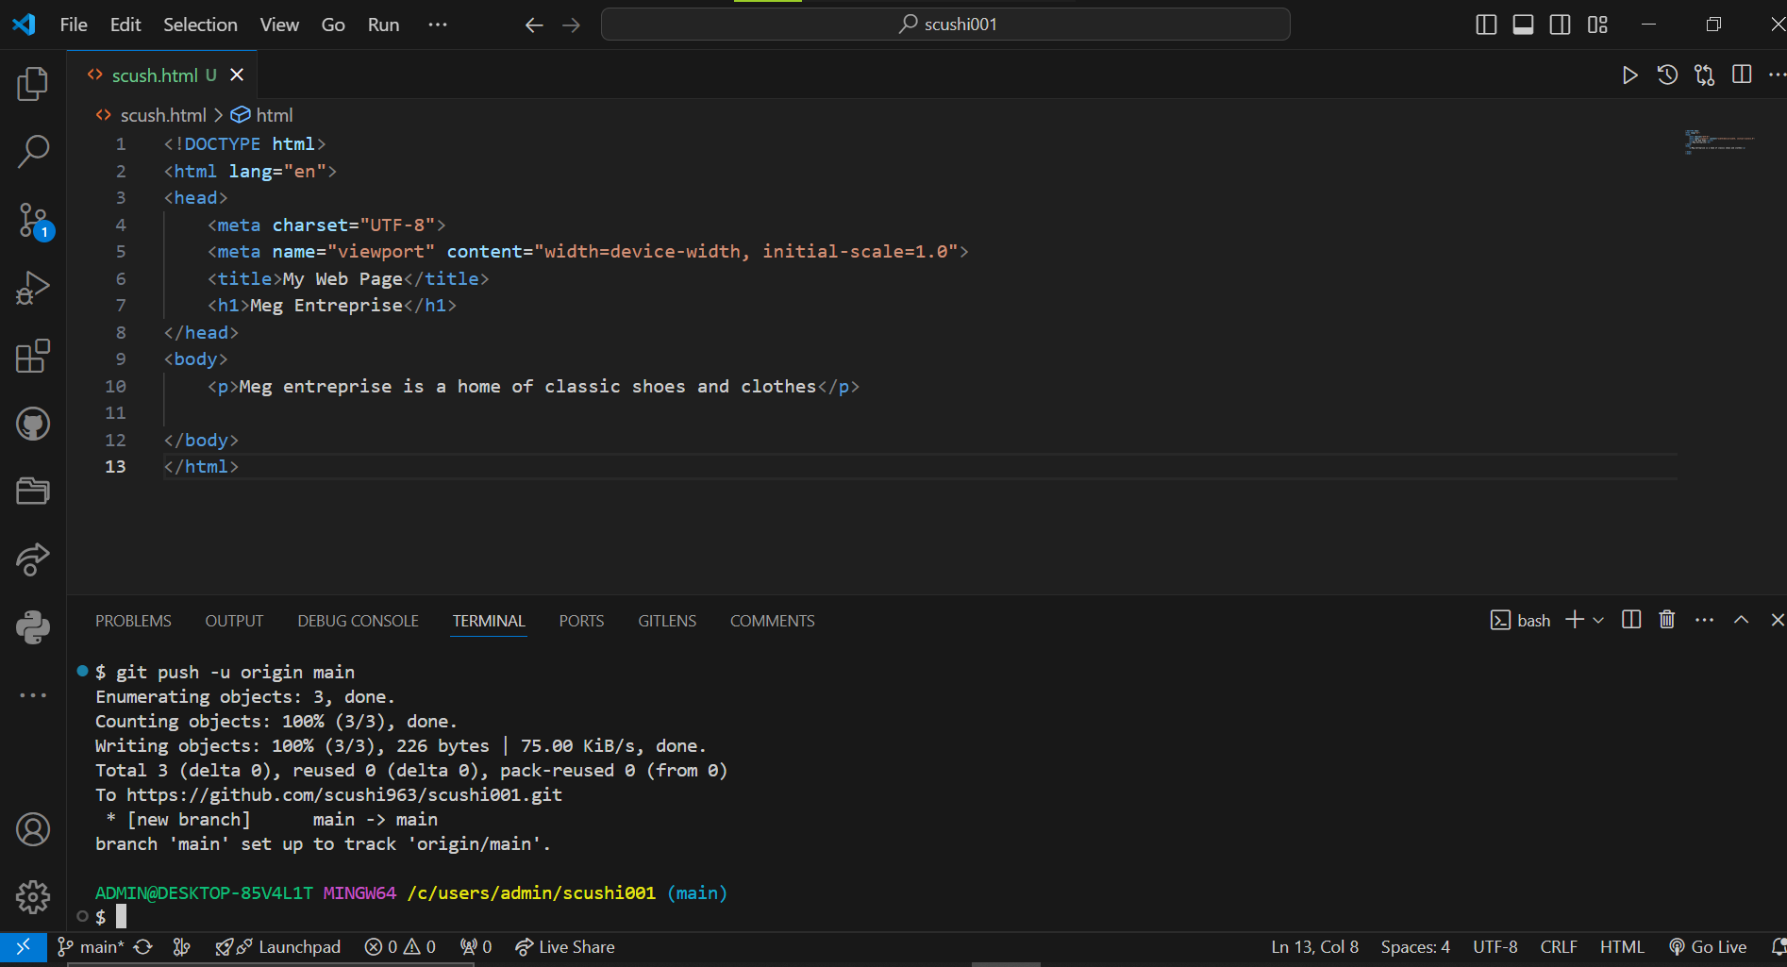

By following these steps, you can effectively use Git for version control in VS Code, allowing you to track changes, collaborate with others, and maintain a history of your codebase.

Submission Guidelines:

- Your answers should be well-structured, concise, and to the point.

- Provide screenshots or step-by-step instructions where applicable.

- Cite any references or sources you use in your answers.

- Submit your completed assignment by 1st July